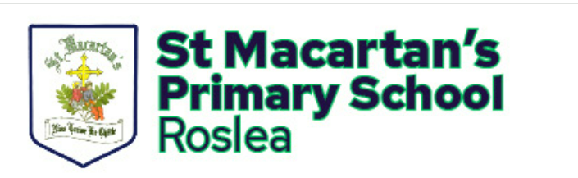
Principal: Mrs Caroline Rooney Tattynageeragh
Telephone: 02867751100 Roslea
Email: info@stmacartans.enniskillen.ni.sch.uk Co. Fermanagh
Website: www.stmacartanspsroslea.com BT92 7AW

Dear Parents and Carers,
We are delighted to inform you that our school is taking part in the Being Well, Doing well programme- an initiative focused on promoting wellbeing across our school community. As part of this we are asking parents and carers to share their views about wellbeing at our school. Your feedback is important and will help us understand what’s working well and where we can continue to improve
Taking part is simple-just scan the QR code below using your smartphone or tablet and it will take you straight to our short wellbeing survey.

Thank you for your time and continued support.
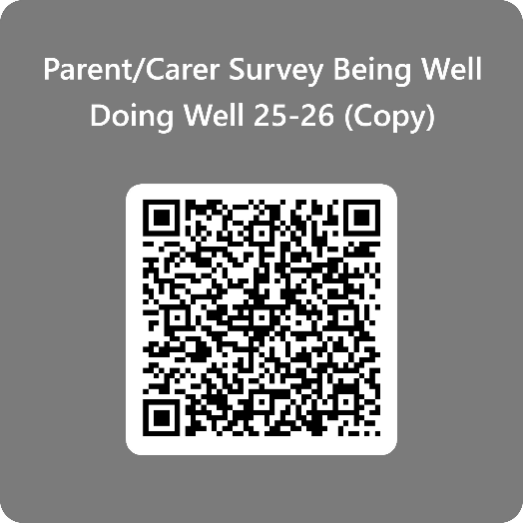
Yours sincerely,
Mrs Keenan
Being Well, Doing Well Coordinator

